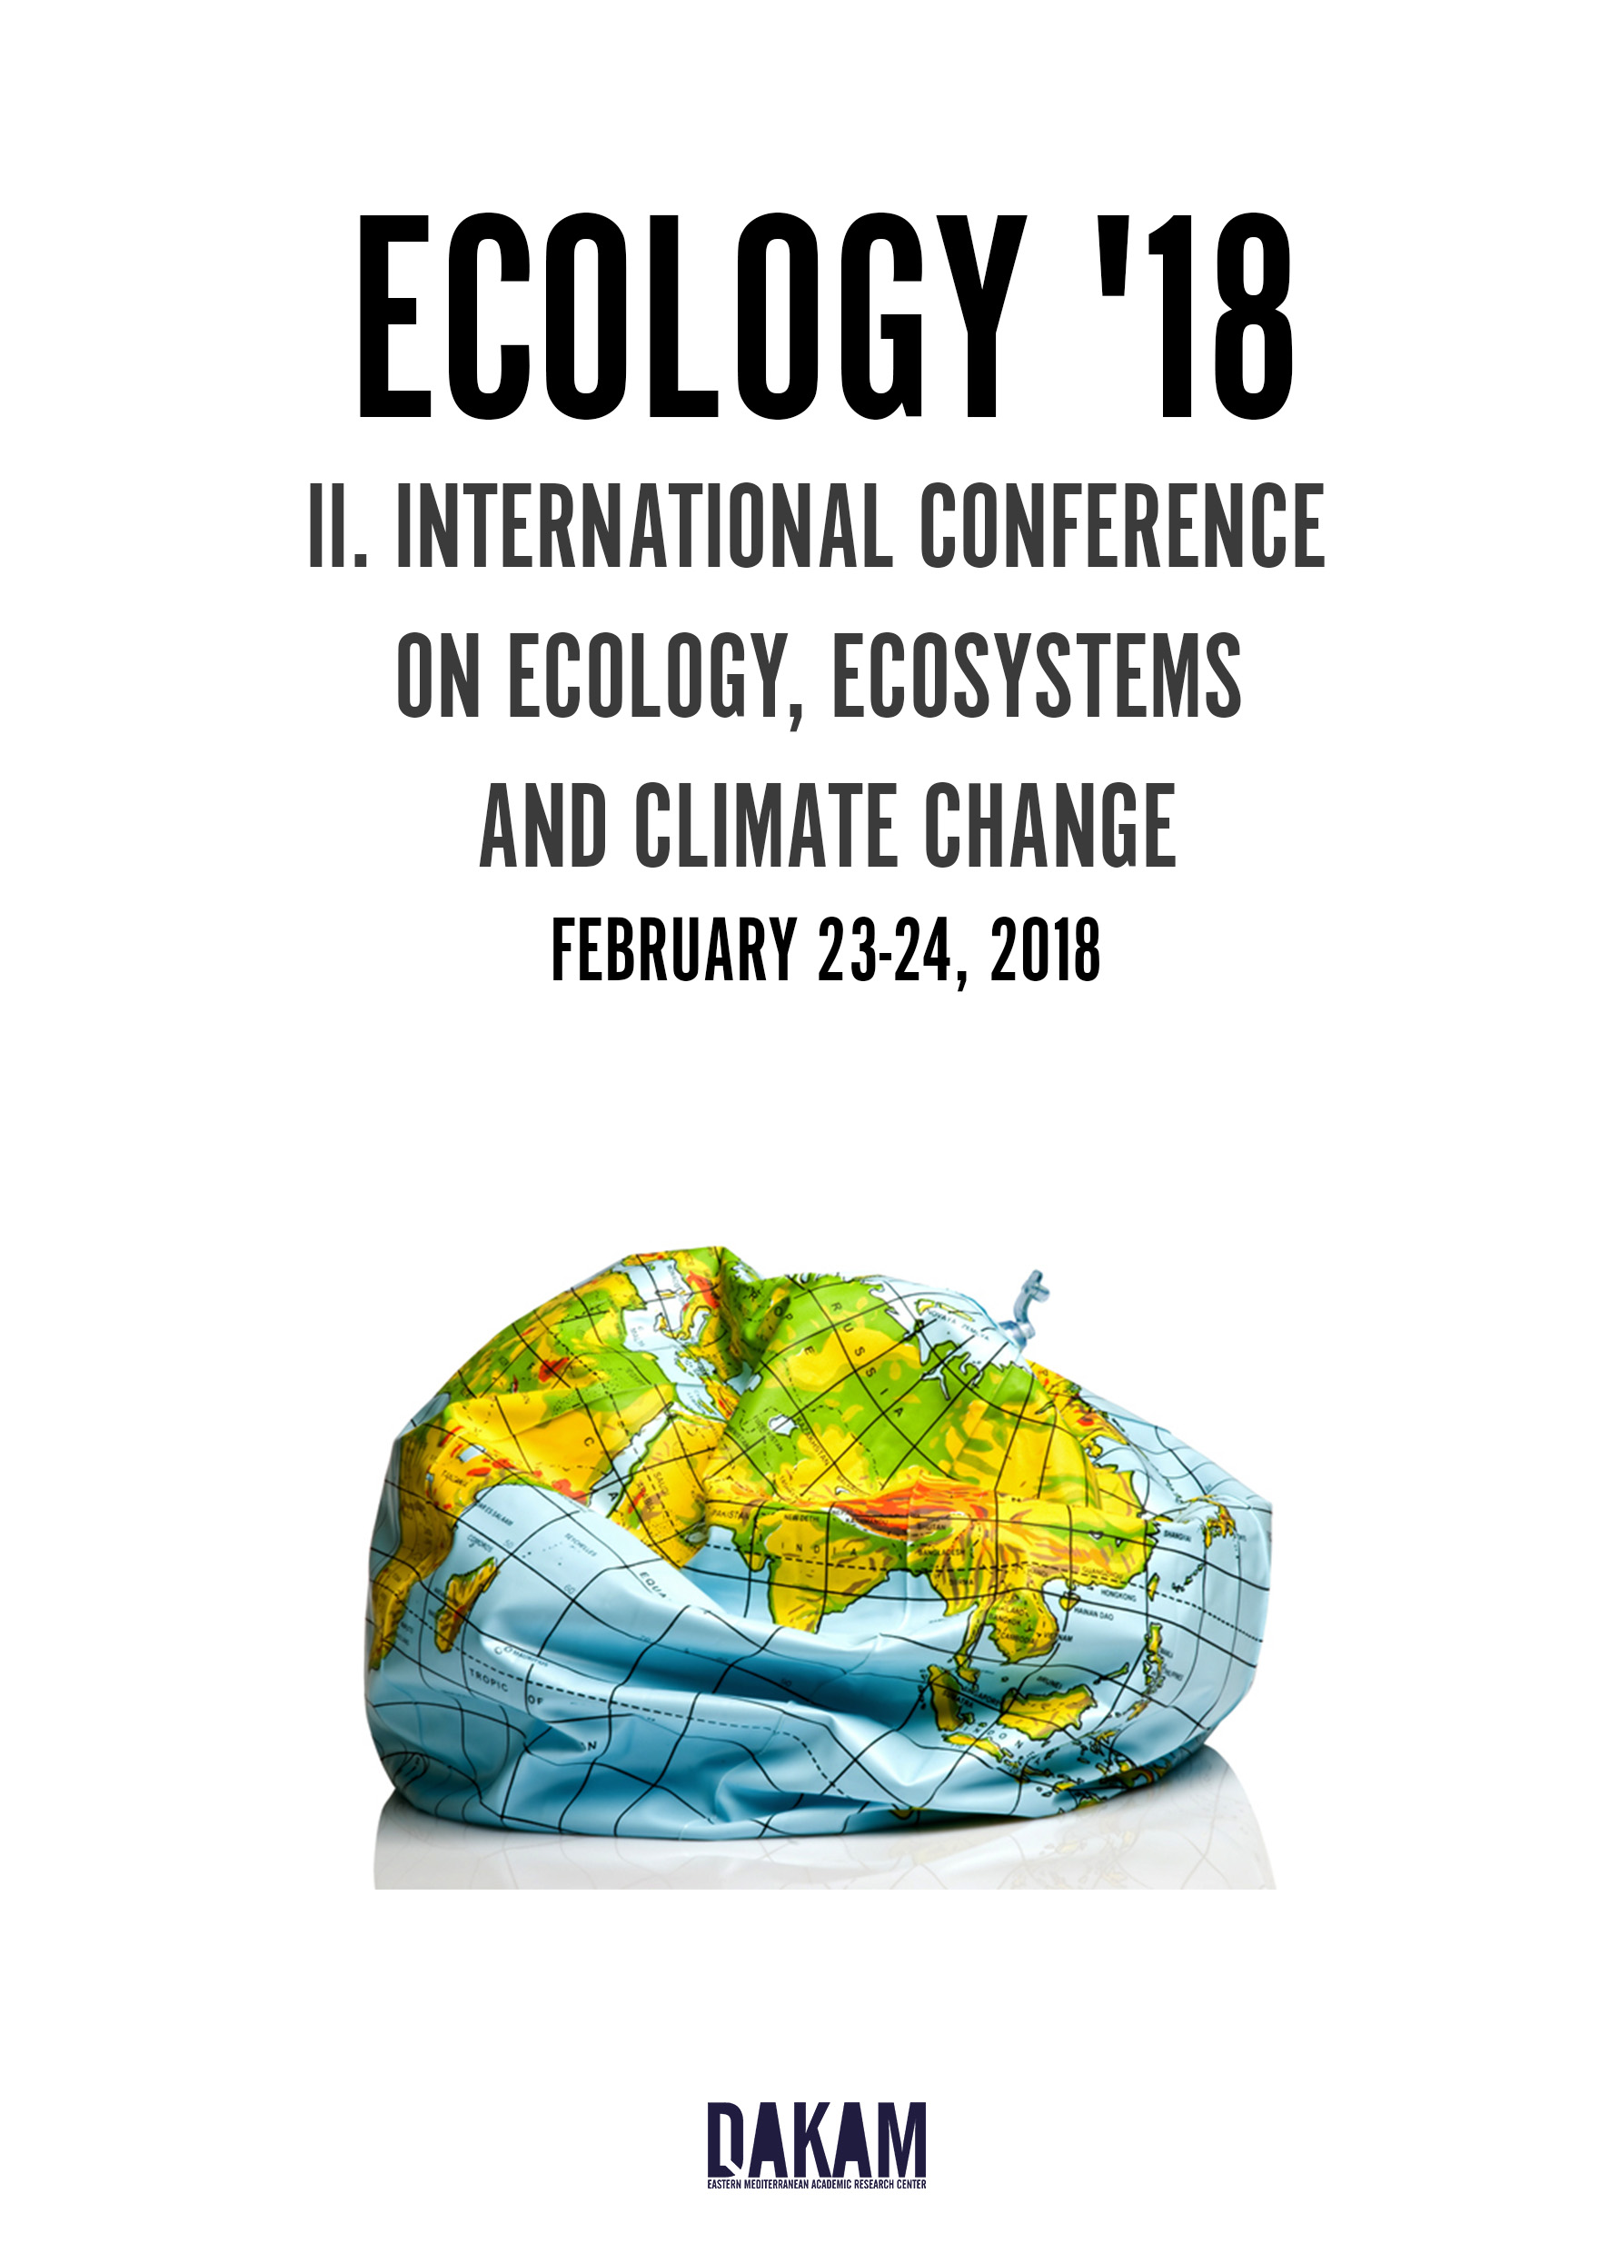

**IN PERSON PRESENTATIONS**

NIPPON HOTEL, TAKSIM, ISTANBUL / FEBRUARY 23

10:00 REGISTRATION

*10:15 OPENING REMARKS*

**10:30 KEYNOTE LECTURE BY MEHMET BURÇIN PIŞKIN**

*11:00 DISCUSSION*

**11:15** **VEDIA AKANSU**

A CRITICAL VIEW TOWARDS THE PROTECTION OF THE ENVIRONMENTAL VALUES IN RURAL AREAS: WESTERN COAST SETTLEMENTS – KYRENIA

**11:30** **SIBGHA NOREEN, MUHAMMAD ASHRAF, NAILA KHALID**

ADAPTATIVE MEASURES TO HARVEST POTENTIAL YIELD OF SOYBEAN [GLYCINE MAX (L.) MERR.] UNDER VARIED ENVIRONMENTAL CONDITIONS

*11:45 DISCUSSION*

12:00 LUNCH

**13:00 JOSEPH MUIRURI KARANJA, KENICHI MATSUI, HESBORN ANDOLE ONDIBA, ELIUD KIPROP AND BENARD KWAME OPPONG-KUSI**

FRAGMENTATION IN THE IN-SITU AND EX-SITU CONSERVATION OF LAKE NAKURU NATIONAL PARK

**13:15** **NEBIL YUCEL**

EFFECTS OF TERRESTRIAL INPUTS ON THE QUALITY OF COASTAL WATERS IN NORTHEASTERN MEDITERRANEAN

**13:30 OZLEM BOYDAK, ISMAIL EKMEKCI, MUSTAFA YILMAZ, HASAN KOTEN**

ENVIRONMENT FRIENDLY TECHNOLOGY: ORGANIC RANKINE CYCLE (ORC) ENERGY RECOVERY SYSTEM

*13:45 DISCUSSION*

*14:00 COFFEE BREAK*

**14:15** **HAYET BELMESKINE**

EARTHWORM BIOMARKERS APPLIED IN ECOTOXICOLOGICAL STUDY OF SOILS

**14:30** **KELTOUM BENAISSA, MOHAMED BELHAMRA**

INTERFERENCE OF WEEDS SPECIES IN HENNA FIELDS

**14:45 NAZAN BALBABA**

ORGANIC VITICULTURE

**15:00** **SUMEYRA BEKLEVICUYLASI, MEHMET BURCIN PISKIN, EMEK MOROYDOR DERUN**

ECOFRIENDLY NATURAL DYE SYNTHESIS INSTEAD OF SYNTHETIC DYE FOR DYE SENSITIZED SOLAR CELLS

*15:15 DISCUSSION*

*CLOSING REMARKS AND CERTIFICATE HAND-OUT*

**POSTER PRESENTATIONS**

**EYUP EREN, EMEK MOROYDOR DERUN, SABRIYE PISKIN**

INVESTIGATION OF THE EFFECTS OF BORIC ACID AND BORIC ACID WASTES ON ALKALI ACTIVATED FLY ASHES

**FATIMA HIOUANI**

STUDY OF SOME PHYSICO-CHEMICAL PROPERTIES OF THE SOILS IN THE REGION OF AIN BENOUI BISKRA

**GIZEM YILMAZER, SABRIYE PIŞKIN**

THE EFFECT OF FUSION TEMPERATURE ON SILICA EXTRACTION FOR ZEOLITE SYNTHESIS

**NADJIB BENOSMANE, BAYA BOUTEMEUR, S.M HAMDI, MAAMAR HAMDI**

PHYSICO-CHEMICAL CHARACTERIZATION OF THE MUNICIPAL WASTEWATERS OF OUED EL HARRACH, AN EVALUATION OF POLLUTION DEGREE WITH HEAVY METALS

**NADJIB BENOSMANE, BOUTEMEUR BAYA, HAMDI M.SAFOUANE, HAMDI MAAMAR**

OPTIMIZATION OF PARAMETERS INFLUENCING PHENOL REMOVAL FROM SYNTHETIC WASTEWATER USING POLYMERIC INCLUSION MEMBRANE

**SARRA AYACHE**, **CHAKALI GAHDAB**

ATTEMPT TO BREED TRICHOGRAMMA EMBRYOPHAGUM ON A SUBSTITUTE HOST, POPULATION OF PITYOCAMPA CLADE PROCESSIONARY IN ALGERIA

**SEULGI KANG, DONG-SU KIM**

THE DEVELOPMENT OF ADSORBENT USING INDUSTRIAL WASTES FOR THE PROTECTION OF AQUEOUS ECOLOGICAL SYSTEM FROM THE HEAVY METAL POLLUTION

**VIRTUAL PRESENTATION**

**OZGE SUZER**

THE ANALYSIS OF LEED REGARDING ITS WEIGHTING SYSTEM AND APPROACH ON REGIONAL VARIATIONS

conference@dakam.org - www.dakamconferences.org - https://www.facebook.com/DAKAMTR